Session 12

- Create a CTE using the WITH clause to select all products with a rating above 4.5 from a 'Products' table, similar to how Flipkart or Myntra might highlight top-rated items.
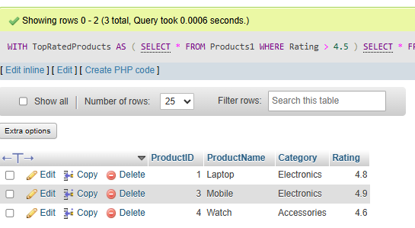

- Rewrite a query that finds all restaurants in 'Ahmedabad' with delivery charges under 50 from a 'Restaurants' table, first using a subquery and then using a CTE. Compare both queries for readability.<br><br><em><strong>Hint:</strong> Focus on making the CTE version cleaner and easier to understand.</em>
Subquery
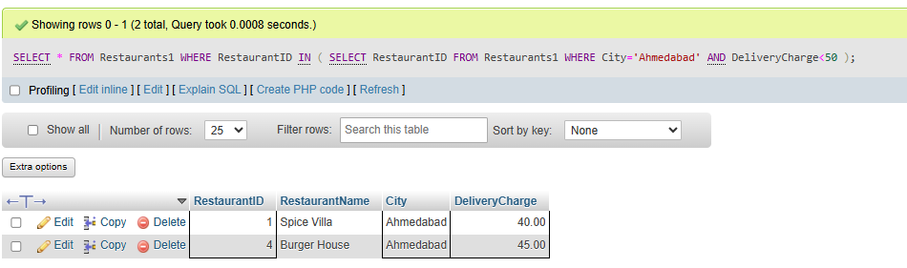

Cte
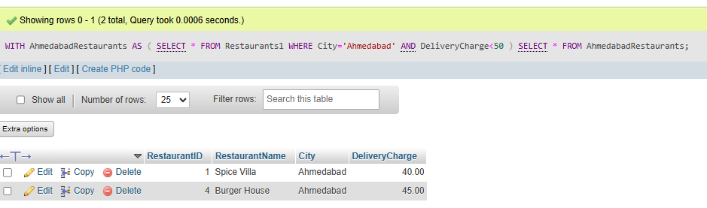
- Using two CTEs in a single query, find the top 3 most-followed users and the top 3 most-liked posts from a 'Users' and 'Posts' table (think Instagram-style data). Output both lists in the same result set.
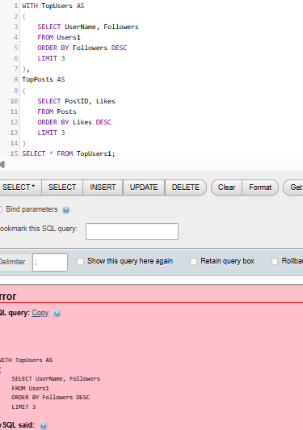

4. Write a recursive CTE that generates a list of dates for the next 7 days starting from today, similar to how BookMyShow shows available dates for movie bookings.<br><br><em><strong>Hint:</strong> Use a base case for today and recursion to add one day at a time.</em>
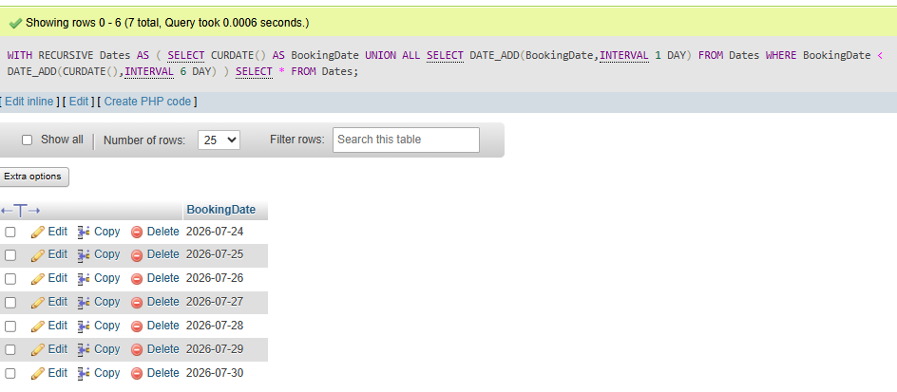

- Given a messy SQL query that finds all users with more than 1000 followers from a 'Users' table, refactor it to use a CTE for better clarity and maintainability.
